Acceptance Testing

# Story A-6: Business Process

As the administrator, I want to understand the process behind the delivery of a package so the company can scale as it grows.

## Acceptance Criteria

A form “field” that includes the process type that will be utilized, will be added to the order “form”. Another tab will include a picture field that shows the varying types of models utilized to deliver the item. IE Corporate or private, etc.

* The process models must not violate any modelling conventions

## Test 1

The business process model does not violate any modelling conventions

### Evidence

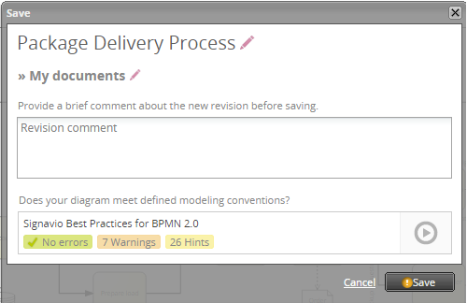

### Result

Pass – the BPMN 2.0 model has no errors (as indicated when saved).

## Test 2

The order form page includes a model.

### Evidence

### Result

Fail – no model displayed on the page

## Overall Results

Test 1 – Pass  
Test 2 – Fail

Only one of two tests have passed for story A6, therefore story A6 has been unsuccessfully implemented completely.

# Story C-1: Customer Account

As a customer I want to be able to register an account so that I don’t have to constantly fill in my information for a delivery

## Acceptance Criteria

The ability to create accounts will be added to the website, to allow clients and staff alike to not have to fill in their information each time

## Test 1

When a new users accesses the website, they are able to create an account for future use.

### Evidence

### 

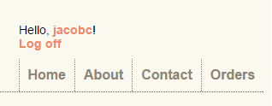

### Result

Pass – Account is created and logged in.

## Test 2

When an account is created, it is stored in the database (only viewable from administrator’s account)

### Evidence

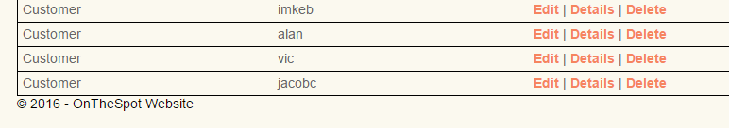

### Result

Pass – The new account (jacobc) is stored in the database.

## Test 3

The account is able to log back in after logging off.

### Evidence

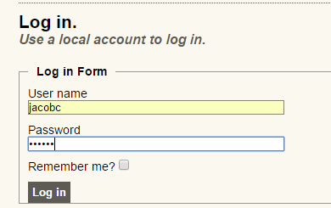  
  


### Result

Pass – The account is able to log back in after logging off.

## Overall Results

Test 1 – Pass  
Test 2 – Pass  
Test 3 – Pass

All three acceptance tests for C-1 passed, so C-1 has been successfully implemented.

# Story A-3: Delivery Flow

As the administrator, I want to know where to send packages – Pickup location, date and time for pickup, date and time for delivery, delivery status so I can ensure the business process is completed with customer satisfaction.

## Acceptance Criteria

* On the website application, there should be a button that leads to a page called “Outstanding Orders”
* The outstanding orders page houses a table that lists pickup location, date and time for pickup, and date and time for delivery
* The relevant parts of the table has to be able to be relayed to the courier doing those specific deliveries

## Test 1

When the admin visits the orders tab they are able to view outstanding orders

### Evidence

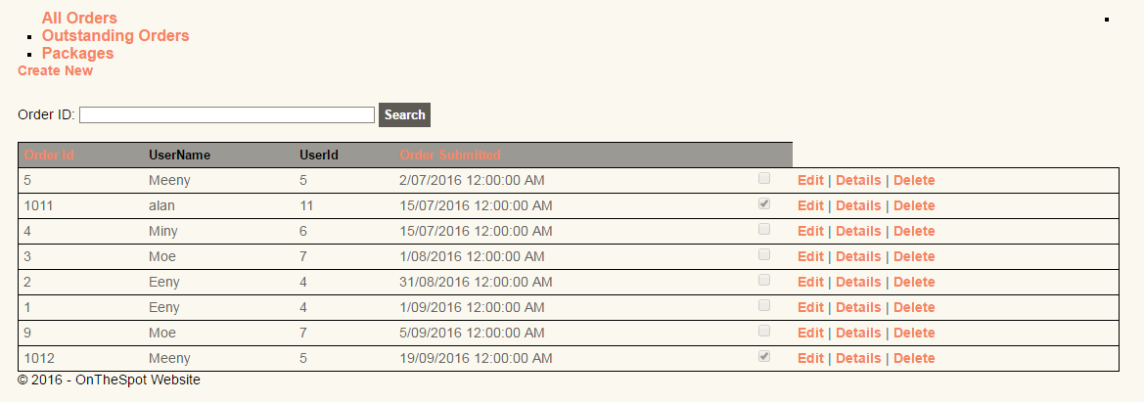  
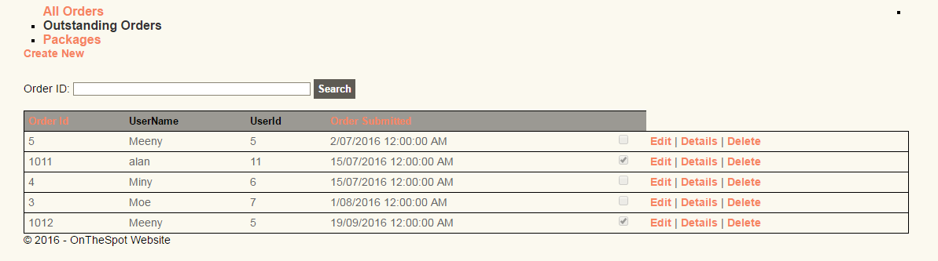

### Result

Pass – There is a button to view only outstanding orders and when pressed filters orders to outstanding

## Test 2

The admin is able to see details on an outstanding order

### Evidence

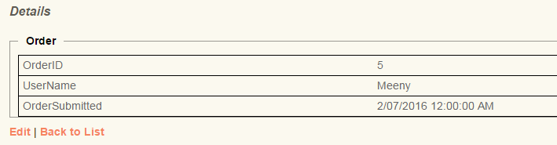

### Result

Pass – when details is pressed, it displays the details for an individual order.

## Test 3

The administrator can forward any outstanding orders

### Evidence

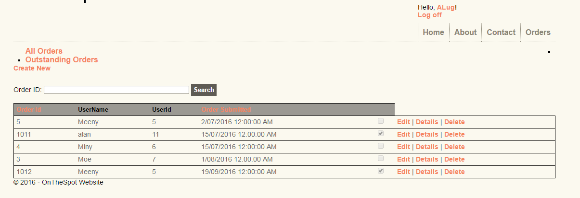

### Result

Pass – when logged into courier account (ALug) they are able to view outstanding orders.

## Overall Results

Test 1 – passed   
Test 2 – passed   
Test 3 – passed

Story A-3 has successfully passed all three acceptance tests so it has been implemented successfully.

# Story A-5: Delivery Type

As the administrator, I want to be able to see the type of delivery (priority, weight, etc.) so I can prioritize and plan delivery runs.

## Acceptance Criteria

In the orders tab there should be a series of fields to explain the type of delivery (priority, weight, corporate or private, etc.)

## Test 1

The order form (for customers) must include series of fields such as priority and pickup

### Evidence

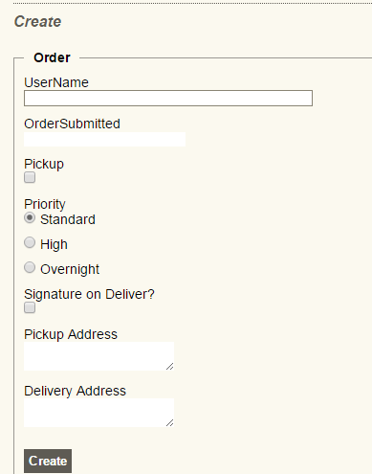

### Result

Pass – Order form allows customers to note their package and delivery attributes

## Test 2

Administration has the ability to view the priority, weight, status and location of packages in the orders tab

### Evidence

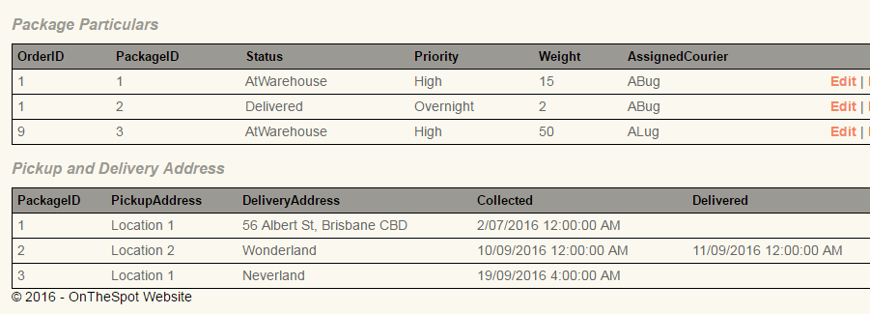

### Result

Pass – database includes status, priority, weight and assigned courier for administration

## Overall Results

Test 1 – Pass  
Test 2 – Pass

Story A-5 has passed both acceptance tests and has been implemented successfully.